Student Performance Prediction System

Project Id: AIML-11

Name : Archie Khunger
Class Roll Number:34
University Roll Number : 2028658
Section and Group: G,G1

Name : Jahnvi
Class Roll Number:09
University Roll Number : 2028436
Section and Group: G,G1

Name : Antriksh gehlot
Class Roll Number:31
University Roll Number : 2028648
Section and Group: G,G1

1 .Problem Description 3
2. Architecture 4
- Models model 5
- Evaluation metrics used 6
- Preliminary Results and Visualizations 7
- References 8

1.Problem Description

The objective of this project is to develop a data-driven system for analyzing and optimizing delivery routes using Python. The system utilizes transportation-related data such as distance, traffic conditions, average speed, and weather impact to estimate delivery time.
The project aims to preprocess and analyze the dataset, apply machine learning techniques to predict delivery time, and implement a path-finding algorithm to determine the most optimal route between two locations.
This approach helps in improving delivery efficiency and supports better decision-making in logistics and transportation systems.

2.Architecture

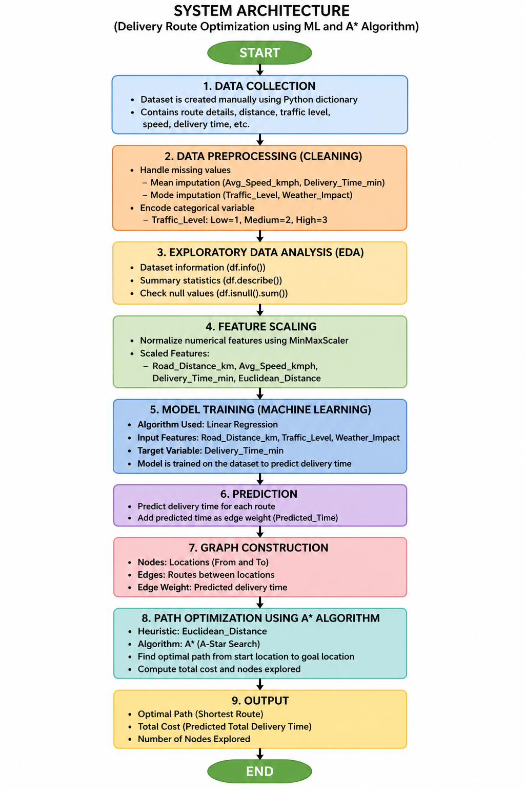

3.Models Used(Applied/ Planned) Give a brief introduction of the models used

The following computational models and techniques are used in this project:
- Linear Regression:
A supervised machine learning algorithm used to predict delivery time based on features such as road distance, traffic level, and weather impact.
- MinMaxScaler:
A normalization technique used to scale numerical features into a range between 0 and 1.
- A* (A-Star) Algorithm:
A pathfinding algorithm used to determine the optimal route between two locations. It combines actual cost and heuristic estimates to efficiently find the shortest path.

4.Evaluation metrics used

The performance of the system is evaluated using the following approaches:
- Predicted Delivery Time:
The Linear Regression model generates predicted delivery times based on input features.
- Cost Function in A* Algorithm:
The total cost of the path is calculated using predicted delivery time.
- Nodes Explored:
The number of nodes explored during the A* search is used to measure efficiency.
At this stage, traditional evaluation metrics such as Mean Squared Error (MSE) can be incorporated in future improvements.

5. Preliminary Results and Visualizations

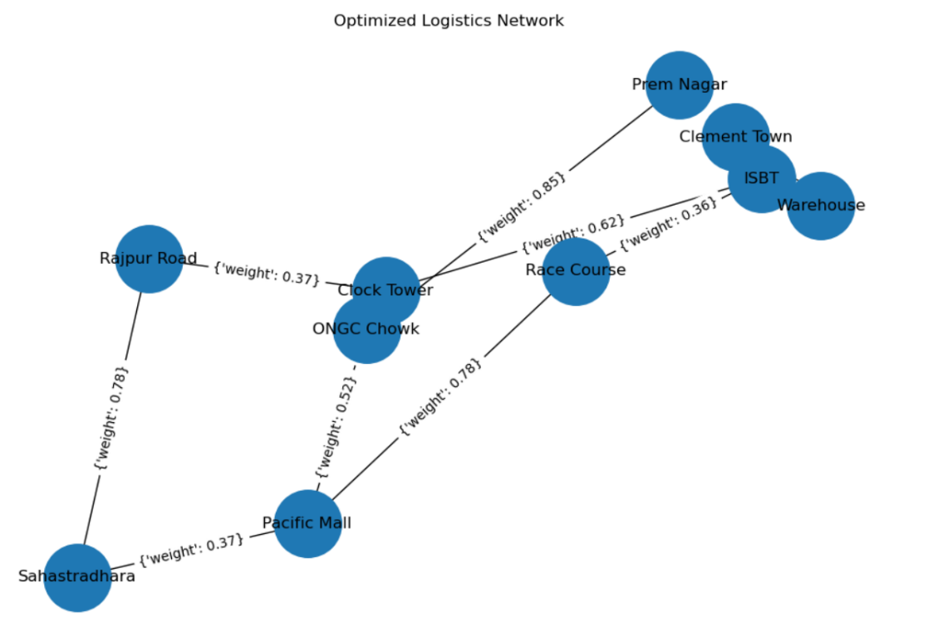

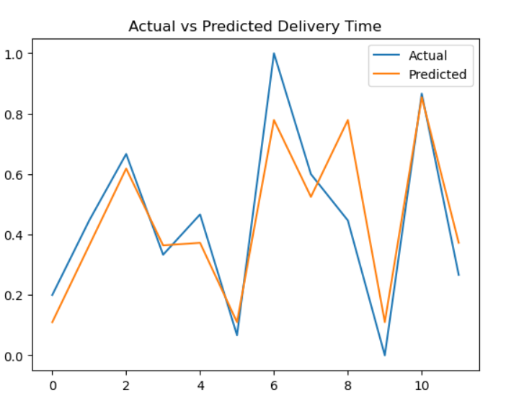

Optimal Path: Warehouse → ISBT → Race Course → Pacific Mall
Total Cost: 1.253
Nodes Explored: 6

The above output shows the optimal route from the source to the destination along with the total cost and number of nodes explored using the A* algorithm.

6. References:
Books:
- Let Us Python – Yashavant Kanetkar

Online Resources:
  - GeeksforGeeks – https://www.geeksforgeeks.org/
  - TutorialsPoint – https://www.tutorialspoint.com/cprogramming/index.htm
  - Stack Overflow – https://stackoverflow.com

